Direct Metal Laser Sintering of Inconel 718

Jacob Keith[1]

**NASA Academy at Marshall Space Flight Center, Huntsville, AL, 35811**

**Direct Metal Laser Sintering (DMLS) is an additive manufacturing technology that NASA hopes to utilize to produce complex J-2X engine parts made of Inconel 718, a nickel-chromium super alloy. We performed a comprehensive series of tensile, low and high cycle fatigue, fracture toughness, and fatigue crack growth tests at temperatures ranging from -320°F to 1200°F. We will use this data to determine whether or not DMLS Inconel 718 is an acceptable replacement for wrought Inconel 718 as a material for parts in the J-2X Engine. Ultimately this study will help NASA improve the strength, durability, and reliability of parts that currently require strength-reducing welding processes to manufacture, while simultaneously reducing cost of production.**

# Nomenclature

*DMLS* = Direct Metal Laser Sintering

FSW = Friction Stir Welding

TIG = Tungsten Inert Gas Welding

EBW = Electron Beam Welding

SLM = Selective Laser Melting

HAZ = Heat Affected Zone

HCF = High Cycle Fatigue

LCF = Low Cycle Fatigue

J1C = Fracture Toughness

FCGR = Fracture Crack Growth Rate

# Introduction

D

irect Metal Laser Sintering (DMLS) is an additive manufacturing technology that succeeds in producing metallic parts with properties very similar to traditional wrought manufactured parts. NASA is interested in the technology because DMLS parts can be “printed” without the need to join and weld multiple pieces together. Welding is typically associated with a Heat Affected Zone (HAZ), inside which material strength and other properties are significantly compromised. Another recent technological innovation to avoid the weakening effects of the heat affected zone is Friction Stir Welding (FSW). Friction Stir Welding works well on large, straight, relatively flat surfaces, but small geometrically complex parts must still be manufactured by some of the more traditional joining techniques such as Tungsten Inert Gas (TIG) Welding or Electron Beam Welding (EBW). Both TIG welding and EBW are accompanied by a heat affected zone where material properties such as tensile and fatigue strength are compromised due to increased likeliness of cracks and brittleness.

NASA builds rocket engines, and most of the material in a rocket engine must not only withstand, but continue operating nominally despite being exposed to extremely severe environments. Over time, materials such as Inconel superalloys, Aluminum-Lithium alloys, and carbon composites have been developed to meet the stringent demands of Aerospace Engineering design, but regions around welds and other stress concentrators are theoretically and historically prime candidate points of origin for failure regardless of bulk material strength. Direct Metal Laser Sintering, or Selective Laser Melting (SLM) as NASA calls it, essentially eliminates the need to join by welding, and in doing so removes much of the uncertainty and risk associated with the Heat Affected Zone (HAZ). Ultimately, the hope is that DMLS is a process that can cut time and cost while enabling the manufacture of stronger, more cohesive, more reliable parts.

## Applications

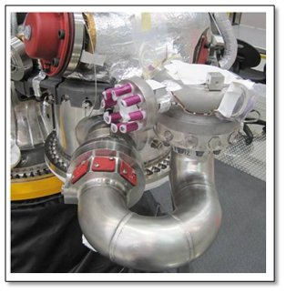

Figure 1. Gas Generator Discharge U-Duct on the J-2X Engine. *Note the TIG welds at 60º angles to piece together the full U-tube.*

There are already several target applications for DMLS Inconel 718. A discharge U-duct in the J-2X engine is required to combat combustion instabilities in the gas generator assembly. This U-duct must be small with a tight turn for acoustical reasons, and currently must be manufactured by the joining of three separate pieces together due to the geometric requirements of the part. This is undesirable because these welds are sources of weakness and are expensive to complete and test for quality assurance. This makes the U-Duct a prime candidate for DMLS manufacture. Additionally, ER50 at Marshall Space Flight Center is hoping to use the capabilities of Laser Sintering to manufacture a hollow, near spherical combustion chamber in one continuous Titanium-based piece for the third stage of a Nano Satellite Launch system that could put small payloads into space. The previous requirement to join multiple sections of the sphere together ruled out the possibility of building a feasible rocket for such small payloads.

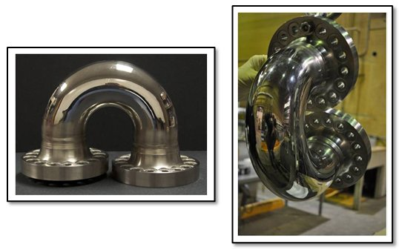

Figure 2. The Gas Generator Discharge U-Duct as a single printed DMLS part. *Noter the lack of welds or joining measures along the curve of the U-duct.*

# Objectives

This study aims to understand how DMLS build parameters impact material properties of the final product. We aimed to answer questions such as: How does build orientation (stacking in x, y, or z axis) impact material properties? What minimum surface roughness can be achieved without post-processing of DMLS builds? How does surface roughness impact the fatigue strength of DMLS products? How does the microstructure of DMLS products compare to wrought Inconel 718? Ultimately, answering these questions will help establish industry standards for DMLS manufactured parts.

# Background

## Inconel 718

Inconel 718 is a material used widely in aerospace due to its excellent thermal and strength properties while retaining a high degree of reliability in extreme conditions. The Inconel 718 super alloy is composed primarily of Nickel, Chromium, and Iron, with lesser amounts of Niobium, Molybdenum, Titanium, and Vanadium. It retains strength properties through 1300ºF, and has excellent resistance to oxidation and corrosion through 1800 ºF. Inconel 718 is a notoriously difficult material to machine because it responds to traditional machining techniques with rapid work hardening, which subsequently tends to damage machining tools. **[1]**

## Microscopy

One of the best methods used to understand a material is to simply look at it. Before any testing on DMLS Inconel 718 began, a microscopy study was performed to better understand the physical reasons for why the material behaved the way it did.

Wrought Inconel 718 is characterized by equiaxed grain structure, with grains that have roughly equal diameters in every direction. There is no directional bias in the growth of grains in traditional wrought Inconel 718. Most of the DMLS samples exhibited elongated grain structure with sharp endpoints. This was a consequence of the sintering process for sequential layers of Inconel 718 powder. While the microscopy study revealed an inherent microstructural difference between DMLS and wrought products, further study would be necessary to determine the specific consequence of these elongated DMLS grains. For the purposes of this study, the goal was to use determine a suitable heat treatment to recrystallize the DMLS specimens in such a way to most closely match the grain structure observed in traditional wrought Inconel 718.

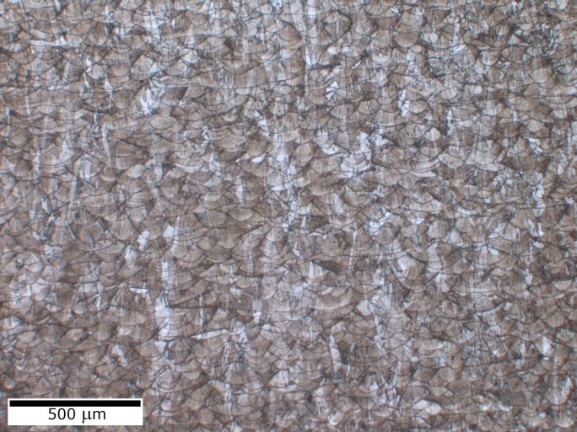

Figure 3. Optical Micrograph of DMLS Inconel 718 microstructure provided by Vendor 1. *Note the elongation of grains.*

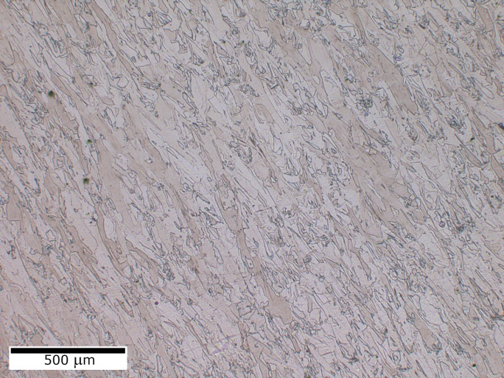

Figure 4. Micrograph of one vendor that succeeded in eliminating elongation of Laser Sintered Grains. *What build parameters produced such a microstructure?*

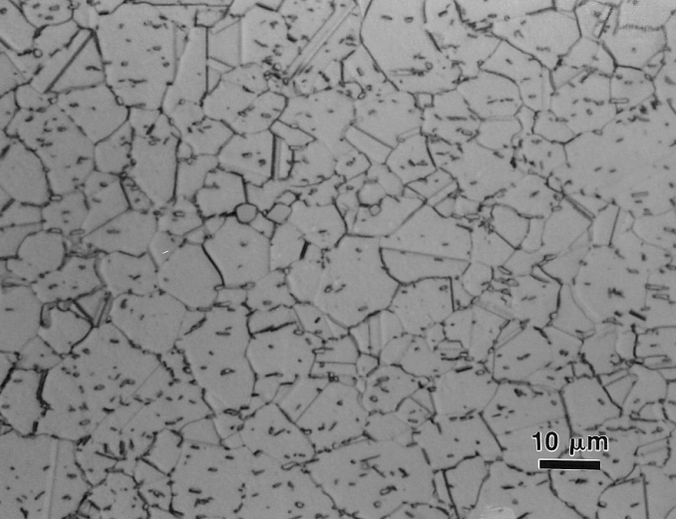

Figure 5. Wrought Inconel 718 Micrograph. *Note roughly equiaxed grains.*

## Heat Treatment

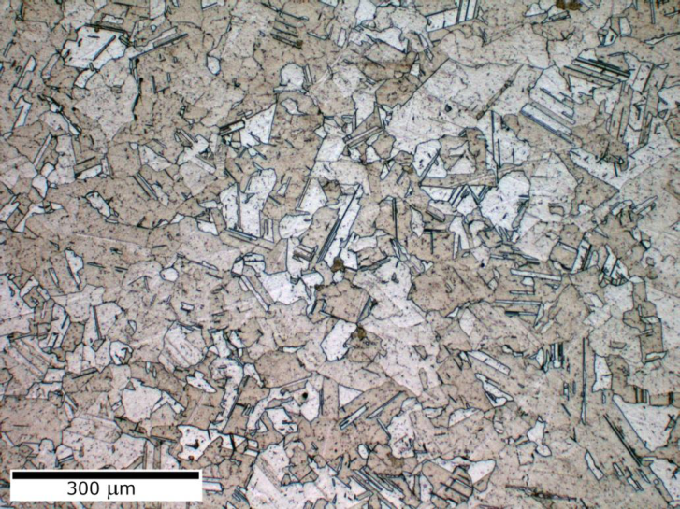

Figure 6. After heat treatment, the DMLS specimen had a more traditional microstructure.

Initial tensile results from as-built samples were sub-par, far less than strengths seen in wrought Inconel. Even the samples provided by Vendor #2, the one that succeeded in producing equiaxial grain structure similar to that of wrought Inconel 718, were relatively weak. Study found that the vendors had stress-relieved the samples at temps above ASTM standards. To correct this, all samples were homogenized via a heat treatment at 2125°F. This freed strengthening elements Niobium and Titanium, which were tied up in the solidification process. After heat treatment, sample hardness increased 30% to acceptable levels. Additionally, DMLS 718 microstructure looked very similar to wrought microstructures on samples from all vendors. Grains were equiaxed, with roughly equal diameters in all directions.

## Surface Roughness

The DMLS J-2X Discharge U-Duct currently struggles to meet traditional standards for surface smoothness. This results from the build methodology. As each layer is added, a support lattice must be utilized to prop up hovering sections. Where these supports are removed, dimples are left behind on the surface (see left). Exterior surfaces can be polished to meet smoothness standards, but tight interior regions cannot be easily reached.

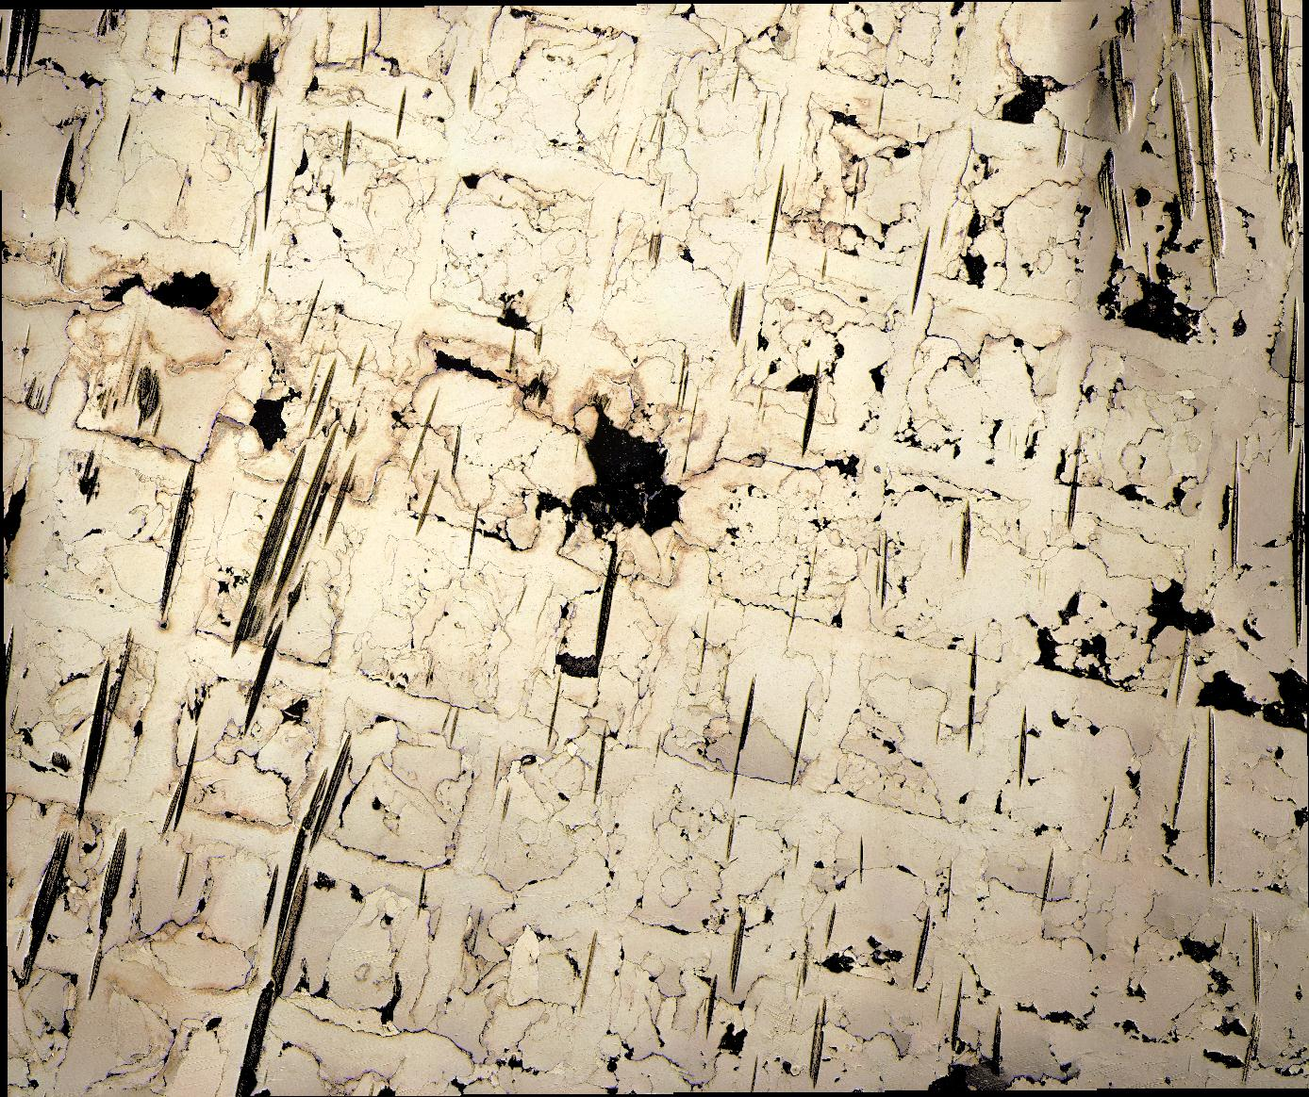

Figure 7. Resultant dimples in surface of DMLS U-Duct after required print support structures are removed.

Surface roughness is known to have a non-trivial effect on fatigue strength of wrought materials. Roughness creates facial areas with a high stress gradient, which serve as ideal points of origin for fracture, and subsequently premature failure of the material. We requested DMLS builds with a maximum surface roughness of 125µin, and none of the vendors succeeded in meeting this requirement.

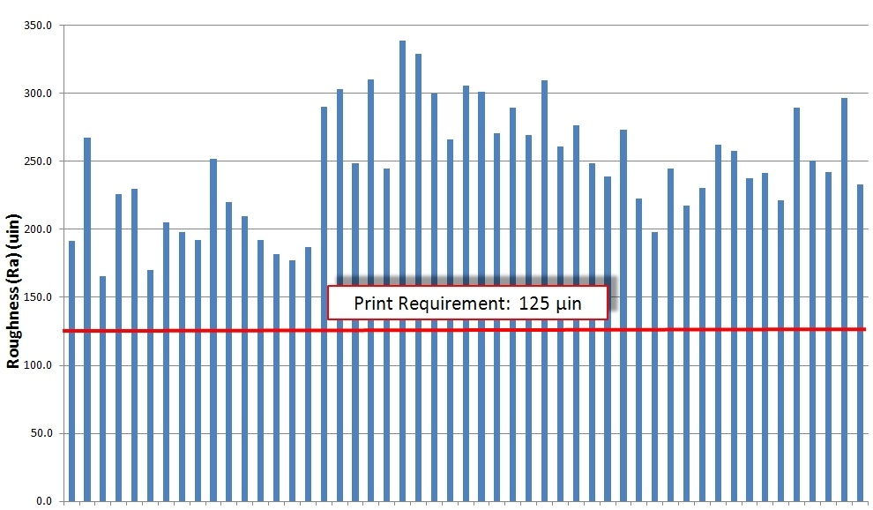

Figure 8. Surface Roughnesses of as-built DMLS Specimens. *Note that all samples exceeded the requested print roughness of 125µm.*

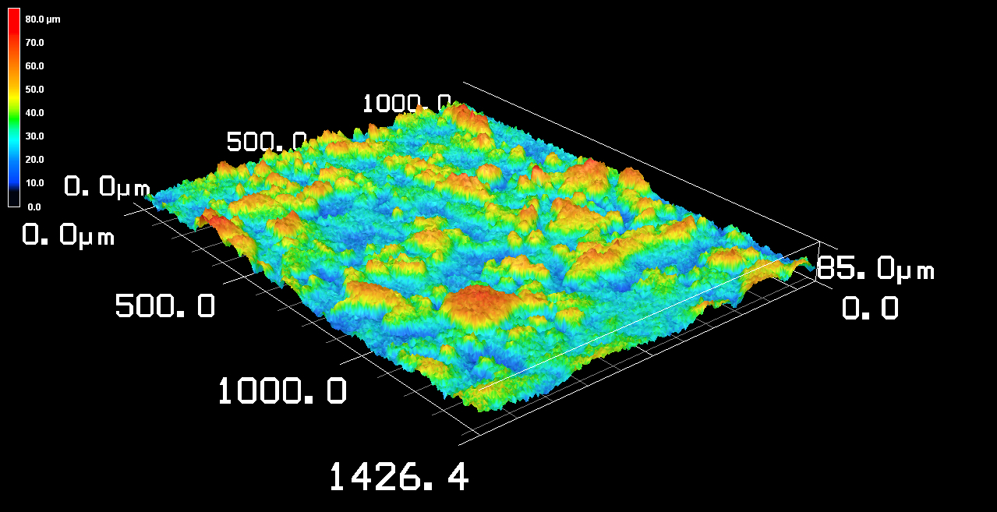

Figure 9: 3D image of the surface of an as-built DMLS sample. *Granular roughness is apparent. Note the raised circular red portions and the depressed blue areas. These granular sources of roughness are the result of individual powder grains that were not fully sintered during the DMLS build. There will always be some inherent surface roughness after the laser sintering build phase for this reason.*

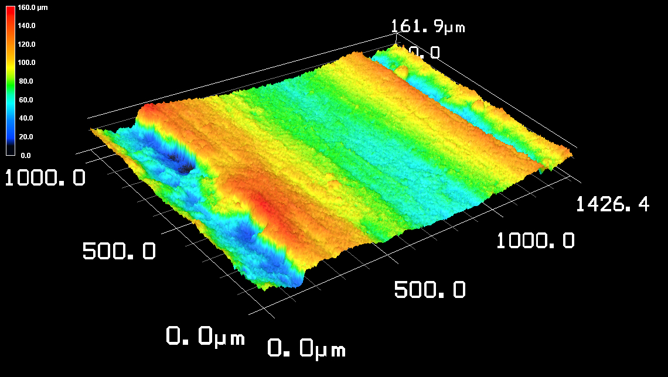

Figure 10. 3D image of an intentional ridge built into one of the vendors’ Tensile samples. *The intention of the ridge is unknown to us, though we suspect it has a strengthening effect. With DMLS manufacture, it is possible to add subtle structural features such as this lengthwise-oriented ridge to fortify structures. Tensile results showed minor improvements in tensile strength in these samples, though whether or not this improvement can be attributed to the ridge has yet to be confirmed.*

# Tensile Testing

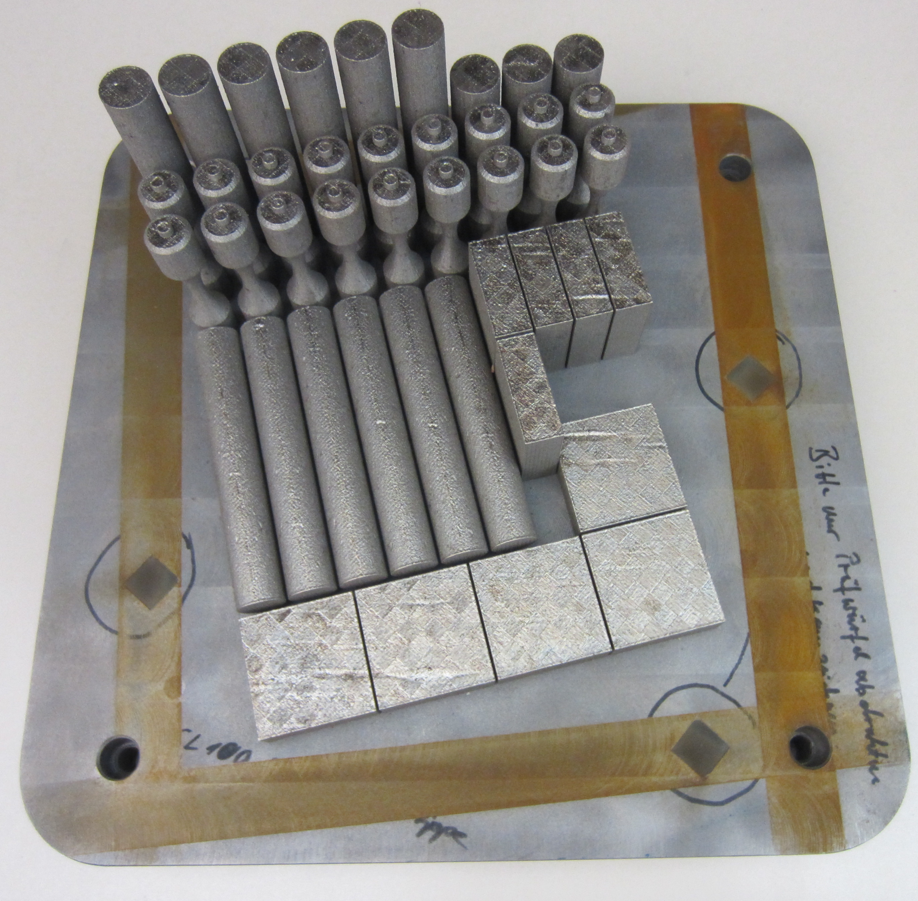

Figure 11. Actual DMLS build product including samples for entire testing phase.

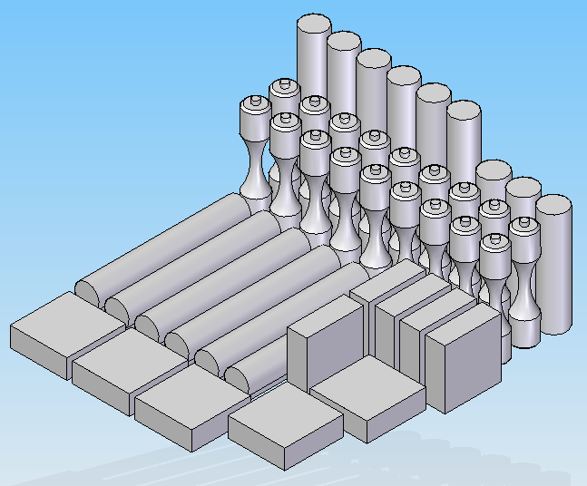

Figure 12. CAD model of the build sample to be printed via DMLS from each vendor.

Build matrixes were requested from each vendor to include samples to test Tensile Strength, Low Cycle Fatigue (LCF), High Cycle Fatigue (HCF), Fracture Toughness (J1C), Creep, and Fatigue Crack Growth Rate (FCGR). The requested samples were delivered while still attached to the build platform from each vendor, and were separated using a diamond wire saw. The samples were treated with the aforementioned heat treatment, and subsequently tested.

## Methodology

Tensile Testing was performed on a standard MTS Tensile tester, outfitted with a suspended ATS tube furnace to fit over the sample. Strain was measured with an extensometer for room temperature samples, and a strain gauge with ceramic arms was used for the high temperature tests. The tensile testing was performed at three temperatures: room temperature, 800°F, and 1200°F. Prior to running the tensile tests, initial parameters were recorded for each sample including specimen hardness, length end-to-end, diameter at the midpoint, and 1” gage markings centered on the midpoint.

After initial measurements were taken, each specimen was in turn loaded into the MTS tensile tester. An extensometer was centered on the midpoint of each specimen to measure the elongation of the sample as the applied tensile load was increased. For the high temperature tests thermocouples were placed at the top and bottom of each sample. Once target temperature was reached for both thermocouples, the specimen was soaked for a minimum of 15 minutes to ensure that the target temperature had time to propagate through the sample. A difference of 80°F between the specimen top and bottom was determined to be the limit for an acceptable temperature gradient, since heat tended to accumulate at the top of the furnace. Tensile tests were then performed, and after failure was reached final measurements were recorded.

## Results

Tensile testing provided information on the Modulus of Elasticity of DMLS Inconel 718, as well as the 0.2% Yield Strength, Ultimate Yield Strength, Elongation, and associated reduction in area at the location of failure. Each characteristic was compared to ASTM values for wrought Inconel 718. After initial tensile test results were shown to be below par, the heat treatment brought tensile strengths and modulus of elasticity up to levels more competitive with wrought Inconel 718. The results of tensile testing at various temperatures are as follows:

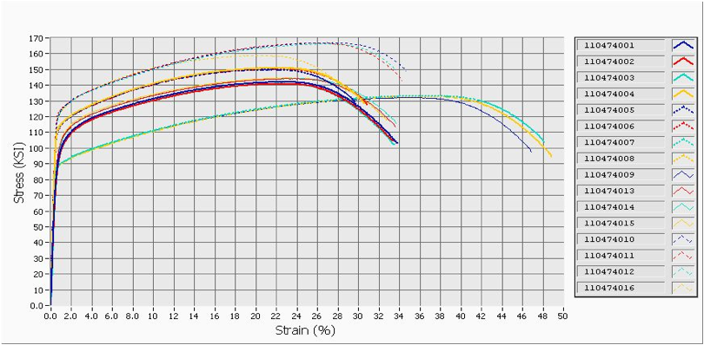

Figure 13. Pre- Heat Treatment Tensile Results of DMLS tensile samples. *Tensile results show a yield approximately 30% lower than expected for traditional wrought Inconel 718, which has a 0.2% Yield around 150 KSI.* [2] *These subpar results initiated the investigation into how grain structure affects strength properties. After heat treatment issues were resolved, sample hardness and tensile strengths improved, seen in subsequent tensile results.*

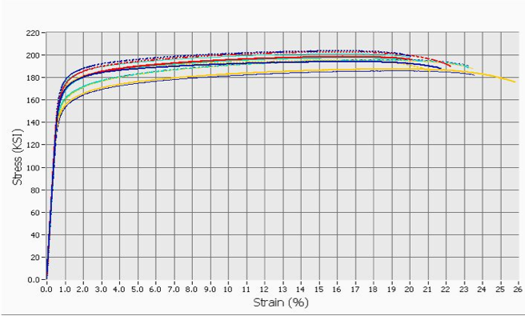

Figure 14. Tensile Tests of DMLS Inconel 718 samples at Room Temperature (RT). R*esults show vastly improved tensile strengths after samples subjected to heat treatment. These tensile strength meet the expected values for wrought Inconel 718.*

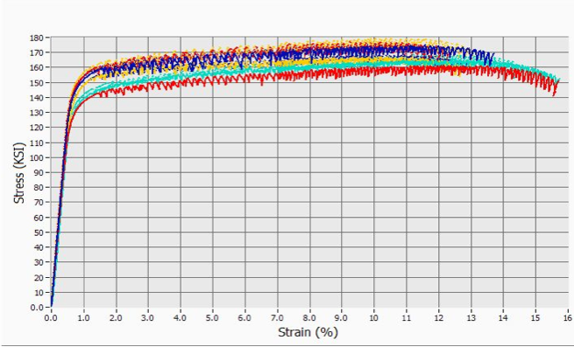

Figure 15. Tensile Tests of DMLS Inconel 718 at 800°F. *Serrations in the Stress-Strain curve post yielding can be attributed to Dynamic Strain Aging (DSA) of the material within a certain temperature regime, and has been observed in other Inconel Alloys. The work-hardening mechanism is a result of the pinning of lattice dislocations due to the diffusion of solute elements into the matrix of the material. To further confirm that DSA is an inherent material property and not unique to DMLS samples, additional tests of wrought Inconel 718 were performed at 800°F. After serrated results were observed, testing of DMLS samples resumed. [3]*

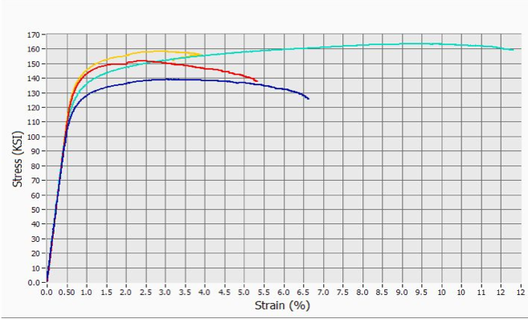

Figure 16. Tensile Tests of DMLS Inconel 718 at 1200°F. *Note the reduction in Tensile Strength at 1200ºF and reduction in elongation (strain) before failure.*

The results of the tensile testing on DMLS Inconel 718 were comparable to values seen in wrought Inconel 718 with regards to Modulus of Elasticity, 0.2% Yield Strength, and Ultimate Tensile Strength. These results suggest that once an appropriate post-build heat treatment is applied to DMLs products, tensile strength is competitive with strengths seen in wrought material.

# High Cycle Fatigue Testing

While Fatigue testing we aimed to understand the source of decreased performance in fatigue strength. Is it attributed to surface roughness, or is fatigue strength of DMLS Inconel 718 suppressed relative to wrought Inconel 718 regardless of surface roughness? This would suggest that fatigue life is inherently a consequence of the DMLS manufacturing process, and less attributable to some necessary post-processing such as polishing.

## Methodology

To understand the effect of roughness on material strength, we performed High Cycle Fatigue (HCF) Tests. The MTS Tensile Tester was programmed to cycle at 40Hz between an upper and lower boundary tensile stress loading. Stress loads ranging between 35% to 75% of Yield Strength were tested to establish a fatigue curve with good statistical confidence. HCF tests were performed at room temperature, 800°F, 1000°F, and 1200°F.

* 1. **Results**

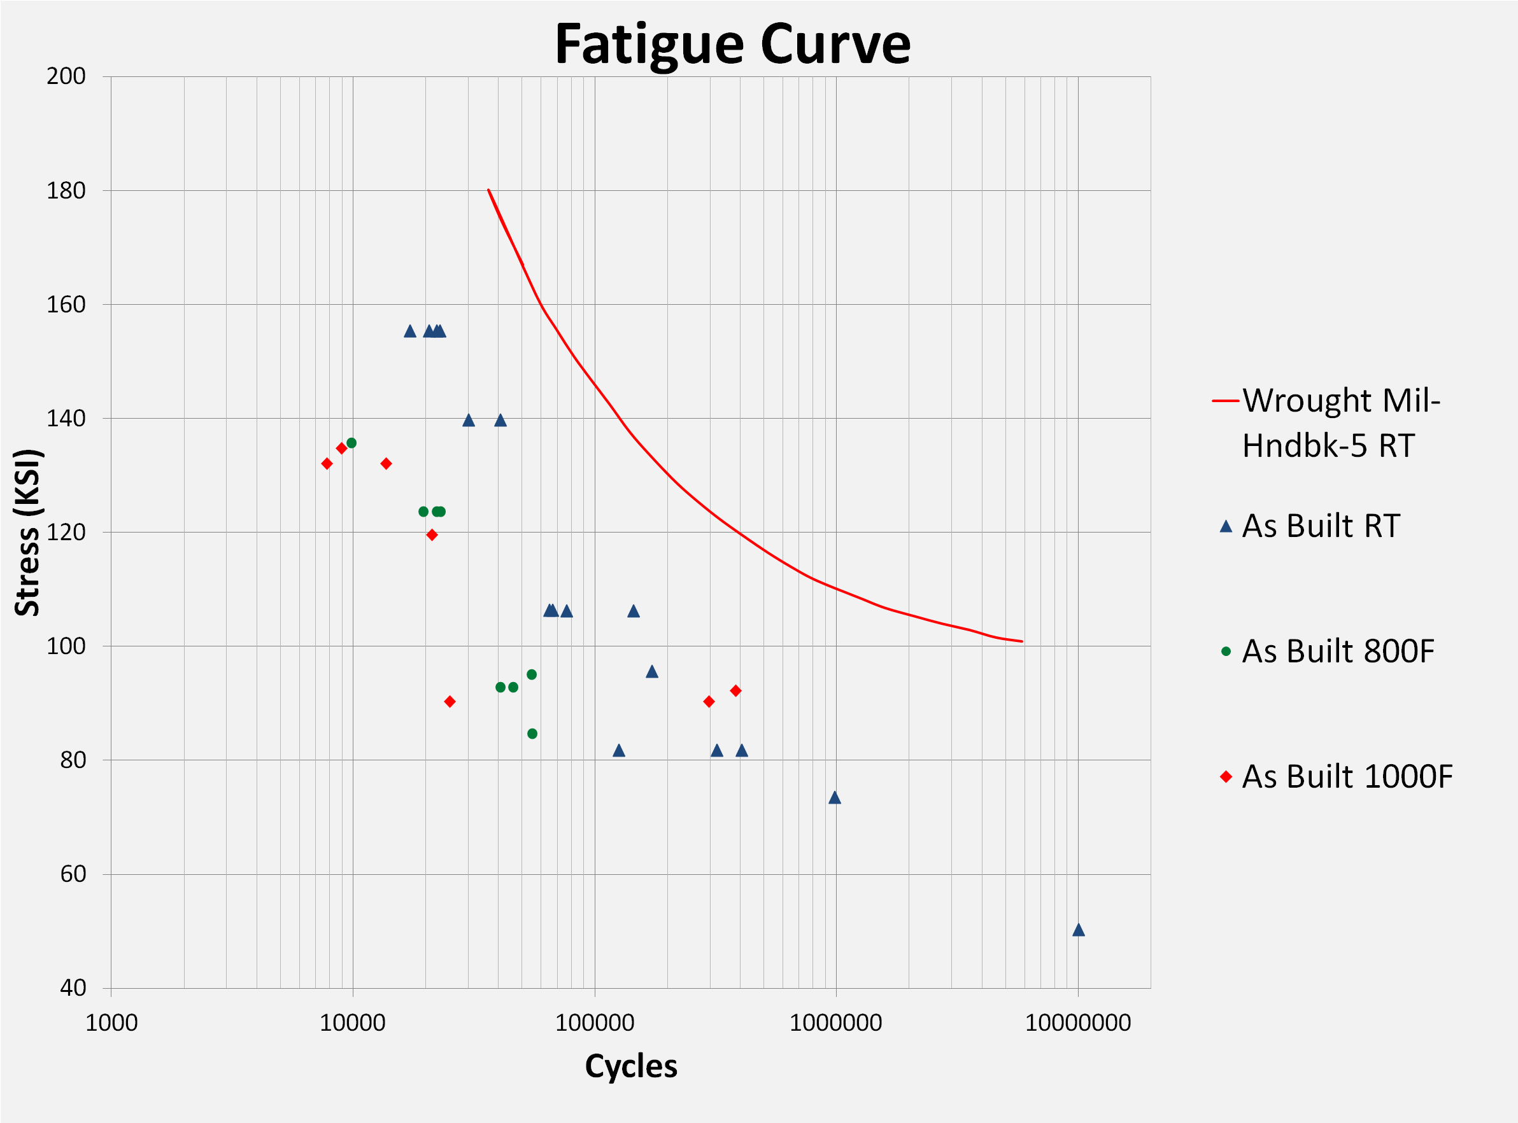

Figure 17. Fatigue Curve for As-Built DMLS Inconel 718. *The red line represents the ASTM standard fatigue curve for wrought Inconel 718, and is compared with the as-built DMLS data points to the left. Fatigue Strength was reduced in the rough, as-built DMLS samples, as shown by the suppressed HCF data points.*

Thus far, only as-built samples have been tested. The above plot shows a noted decrease in fatigue life, as is expected with any sample with a relatively rough surface. At the moment there is little analysis to be made here, other than making a statement that fatigue strength is markedly decreased, by about 30%, with rough DMLS surfaces. The consequence of this reduced fatigue performance in DMLs Inconel 718 is that surfaces affected by the structural lattice supports required to build 3D objects will suffer some decrease in fatigue strength. The real analysis will come when these as-built samples are compared to the performance of polished samples.

# Conclusion

This study shows that Direct Metal Laser Sintering Technology has made substantial progress towards replicating the bulk material characteristics of traditionally manufactured Inconel 718. However, elements such as surface roughness, heat treatment, structural build features, and parts with particularly tight tolerance requirements still present hurdles to overcome before DMLS will be become a comprehensively superior manufacturing method. DMLS does succeed in significantly reducing the cost of manufacturing parts with complex geometries.

In the near-term, DMLS of Inconel 718 shows promise for a variety of NASA applications, especially in the J-2X engine. It is currently at a Manufacturing Readiness Level (MRL) 6, and material specifications must be fully established before progressing to MRL-7. This project has identified final DMLS build specifications such as heat treatment through microscopy studies, and hopes to define surface roughness tolerances to assist this MRL transition.

This study will continue after my departure, and will include comprehensive testing of DMLS Inconel 718 including Creep, Fracture Toughness (J1C), Low Cycle Fatigue (LCF), and Fatigue Crack Growth Rate (FCGR). As the testing moves forward, a new set of questions should be addressed. What differences in build parameters did Vendor #2 utilize to eliminate the grain boundary issues observed in the other two vendors?When Marshall Space Flight Center receives its DMLS machine, what DMLS build parameters should be used to duplicate industry success? How much microstructural difference should be tolerated in regards to Quality Control of DMLS builds?

# Acknowledgments

F. A. Author thanks Tina Malone, Matthew Jackson, Michael Watwood, Chip Moore, Joshuah Clifton, Ken Cooper, and all of EM10 and the Hydrogen Testing Facility for their support on this project.

# References

[1] Hong, S.H, Kim, H.Y, Jang, J.S and Kuk, H, “Dynamic Strain Aging Behavior of Inconel 600 Alloy,” Superalloys, 1996.

[2] Special Metals Corporation. “Inconel Alloy 718”, Special Metals. 2007. Retrieved July 17, 2012. http://www.specialmetals.com/documents/Inconel%20alloy%20718.pdf

[3] Venkatesh, A., Marthandam, V., Roy, A.K. “Tensile Deformation and Fracture Toughness Characterization of Alloys 617 and 718,” Department of Mechanical Engineering, University of Nevada Las Vegas.

1. Research Associate, EM10, Marshall Space Flight Center, Columbia University